Documentation: Connect Spotify Web API to Power BI

🌐 Overview: What is a Web API and How It Helps Power BI Connect to Spotify
A Web API (Application Programming Interface) is a standardized way for applications to communicate over the internet using HTTP requests. APIs expose data and services in a structured format—usually JSON or XML—allowing other applications to read, write, or update that data without needing direct access to the underlying system or database.
In the case of Spotify, their Web API allows developers and external applications to access Spotify's massive music database, including playlists, tracks, albums, artists, genres, audio features, and more. However, since Spotify's data is protected and structured, it only grants access via its Web API to those who authenticate correctly (using secure methods like OAuth 2.0).
🤝 How Web API Helps Power BI Connect to Spotify
Power BI doesn’t connect directly to music databases like Spotify’s. Instead, it uses Web APIs as a bridge to retrieve external data. When connecting to the Spotify API, Power BI acts like a “client” that sends a request over the internet and waits for a response containing the requested data in JSON format.
Here’s how it works in simple steps:
- Power BI sends a request to Spotify’s token endpoint, passing in the client ID and secret to get a temporary access token.
- Power BI uses that token to make a second request to Spotify's data endpoint (e.g., to get playlist tracks).
- Spotify responds with structured data (JSON), which Power BI imports.
- Power BI then cleans, transforms, and visualizes the data inside the report.
This method allows Power BI to connect live to external cloud platforms, like Spotify, and pull in real-time or refreshed data, making it highly useful for dashboards, analytics, and insights—even when the data source isn’t a traditional database or file.

Requirements:
Tool/Account | Purpose
Spotify Developer Account | To get Client ID & Secret
Power BI Desktop | For creating the report
M Language | To write Web.Contents queries
🔐 Step 1: Create Spotify App (Get Credentials)
- Go to https://developer.spotify.com/dashboard
- Log in and click Create an App
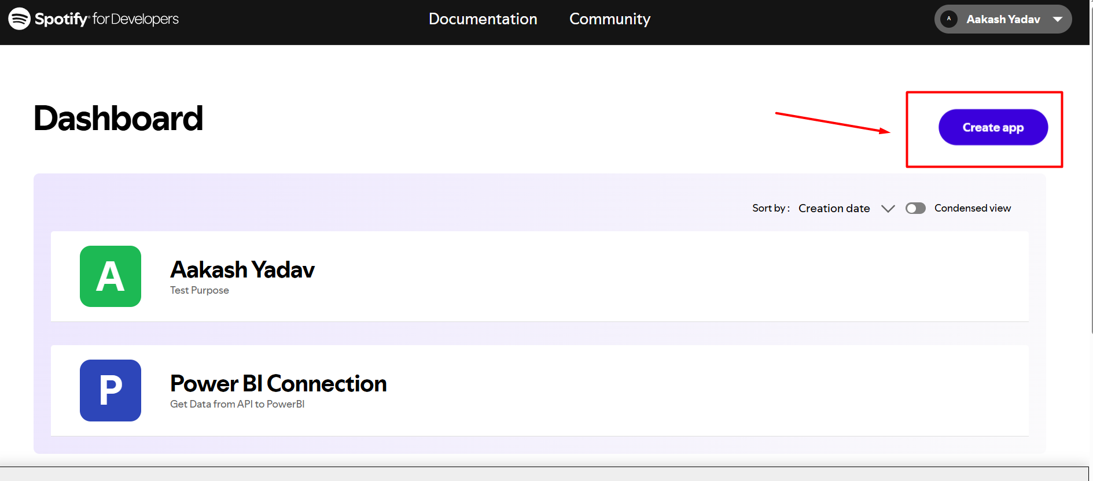

- Provide:
  - App Name
  - App Description
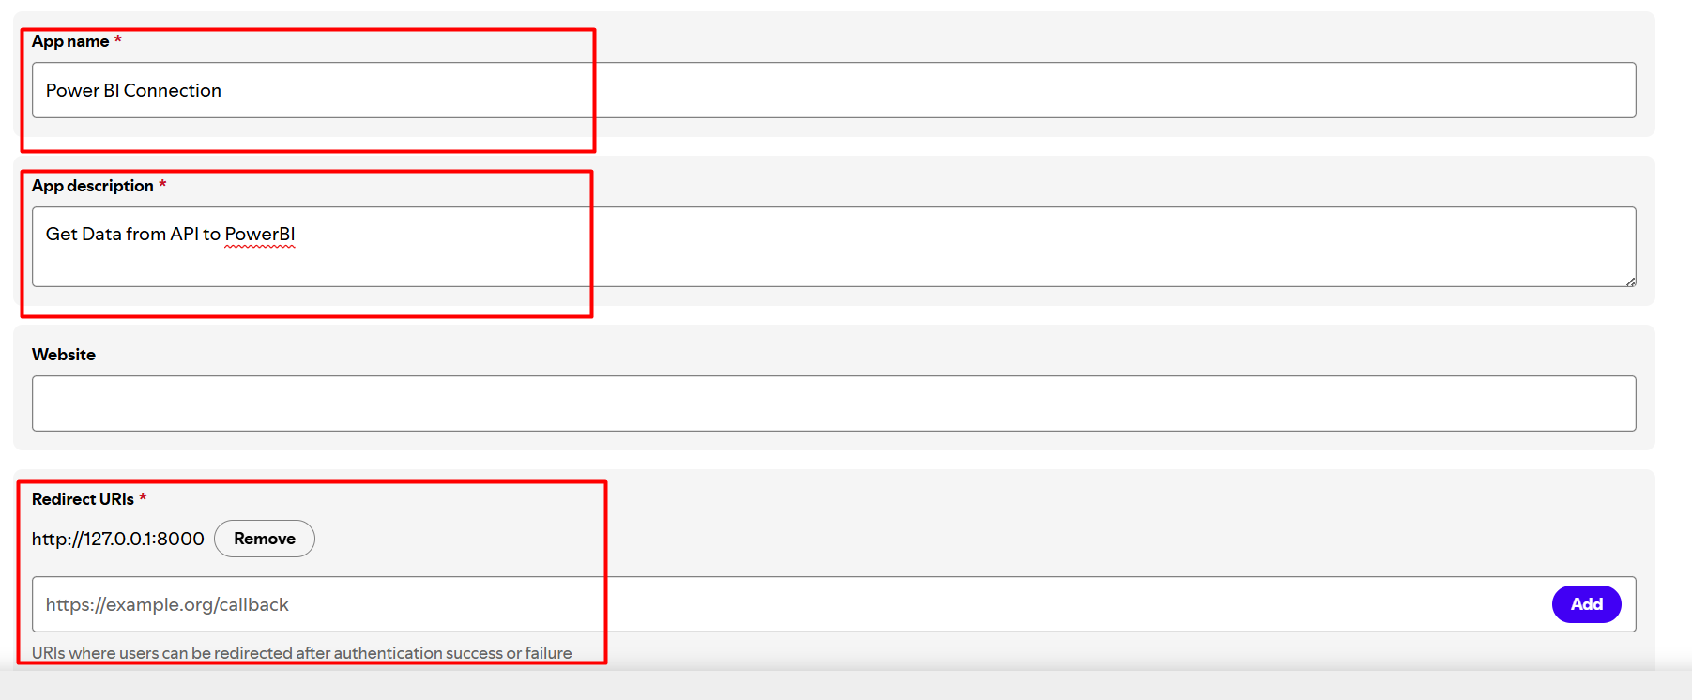
- After creation, copy:
  - Client ID
  - Client Secret
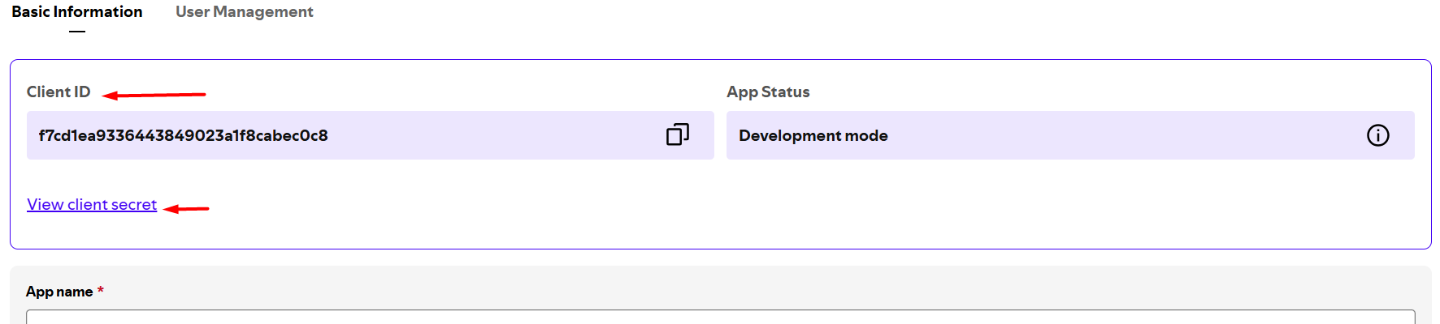
⚠️ Keep the secret confidential. Don't hardcode it in shared files.

🔑 Step 2: Get Access Token (Client Credentials Flow)
Spotify requires a Bearer token using OAuth2 client_credentials.
💻 M Query in Power BI (Advanced Editor):
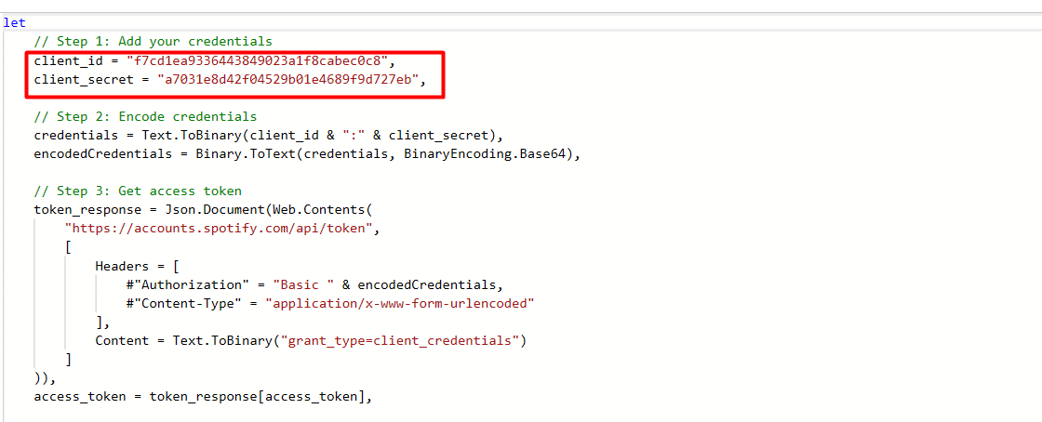

🎵 Step 3: Fetch Playlist Tracks
Use the obtained token to fetch playlist track details.
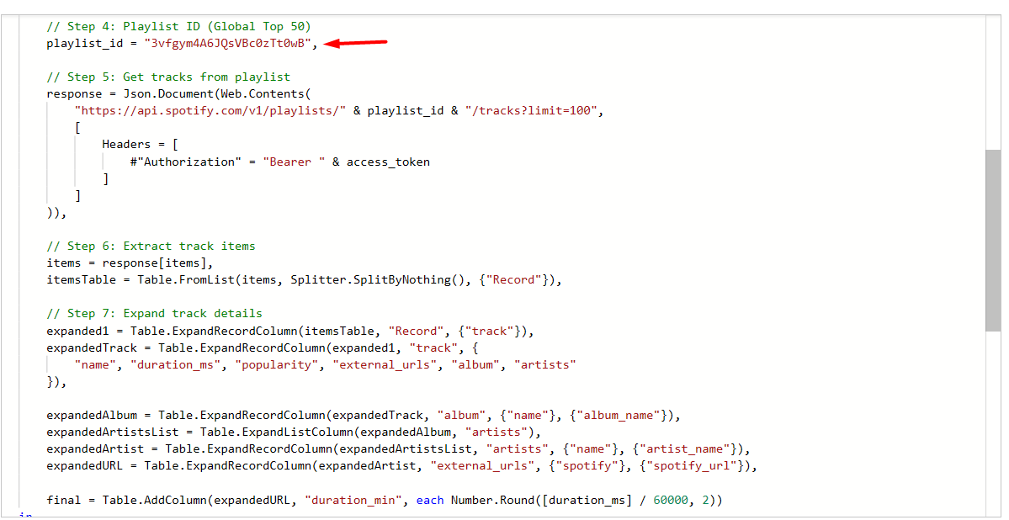

Step 4: Open Power BI Query Editor -> Add new source -> Blank Query.

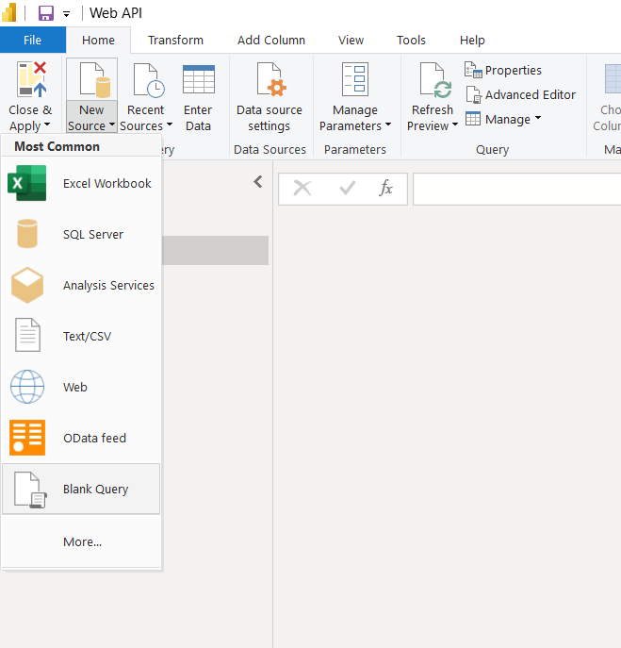

Step 5: Open the Advanced Editor and paste M Code
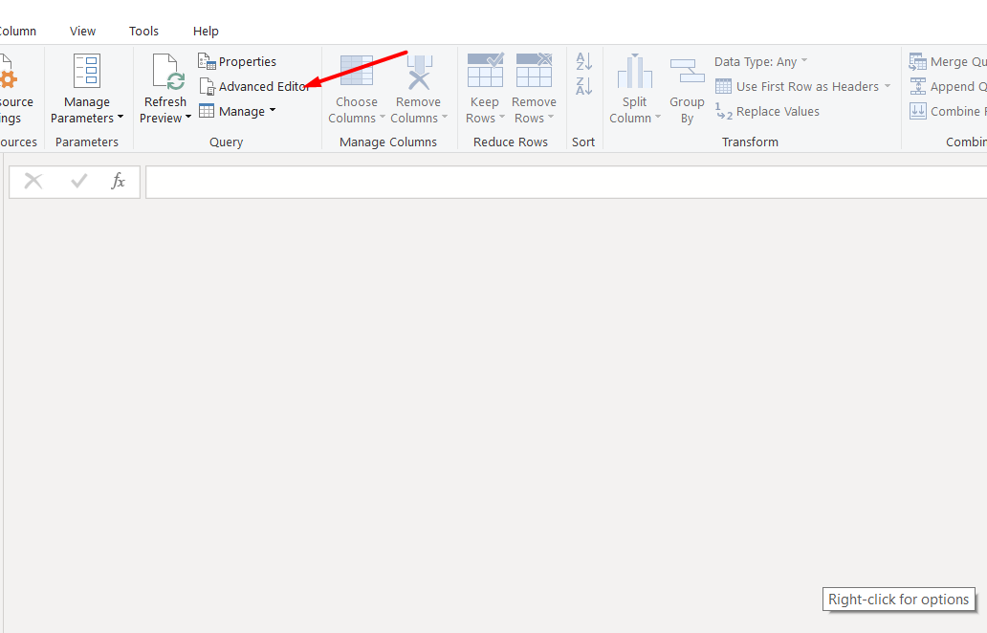

Step 6: Authorized the credentials in Power BI
Use Anonymous access for the web content
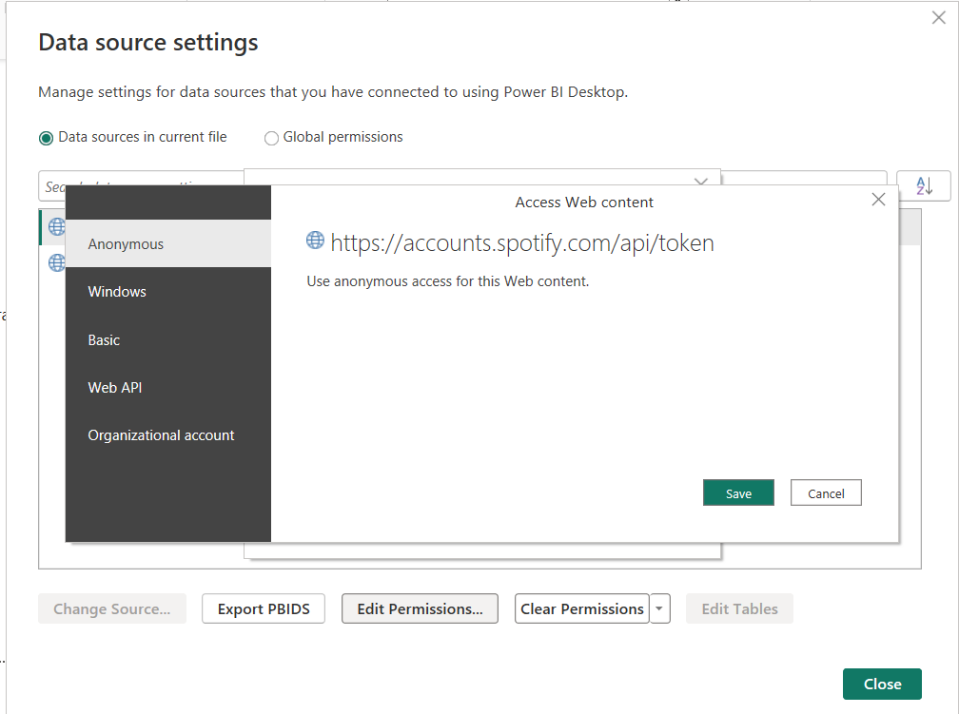
Your final result will look like this
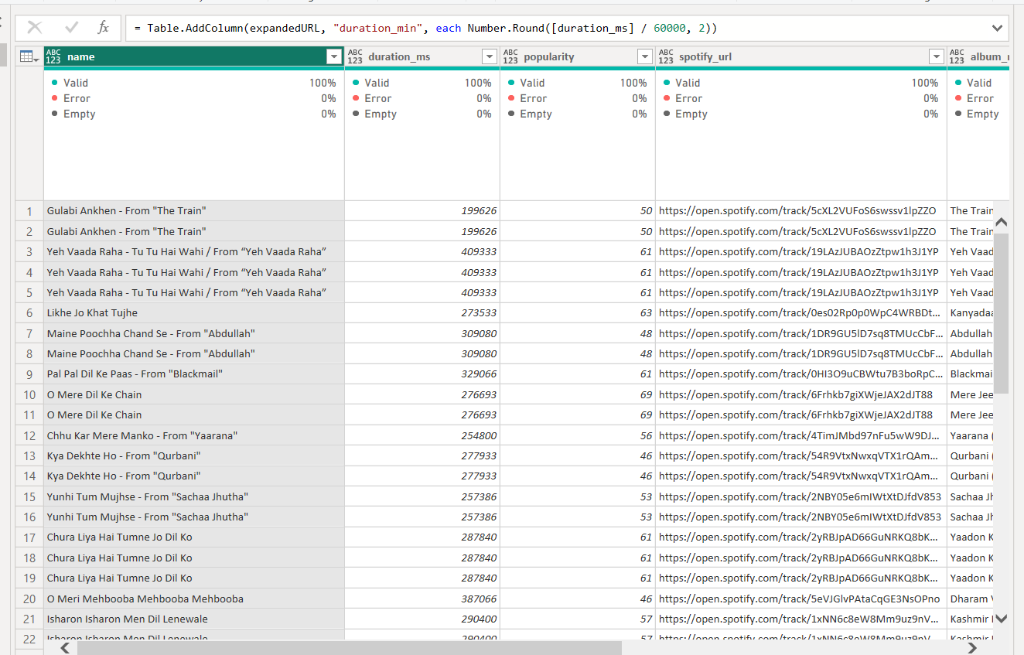

Similary you can also extract the Artists information and Album information by making changes to M Code.

Summary:
This guide outlines how to connect Spotify’s Web API to Power BI Desktop using the OAuth 2.0 client credentials flow to retrieve and visualize playlist data.

